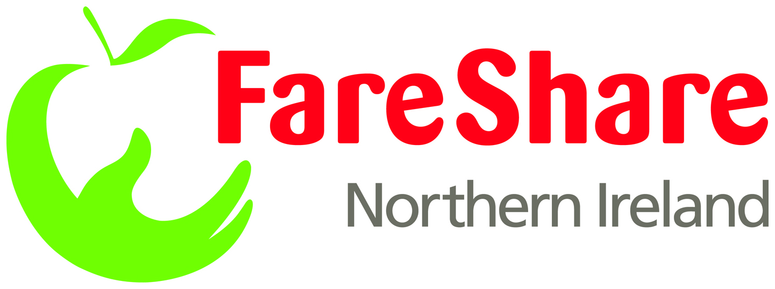
COMMUNITY MEMBER AGREEMENT - FareShare NI

We draw your attention to the liability clause (clause 21), under which you agree to indemnify FareShare against any costs incurred as a result of not adhering to this Agreement.
1. This Agreement is made between FareShare as operated by Council for the Homeless NI and _____________________________ (‘the Community Member’) FareShare NI aims to collect quality food from retailers and caterers, and deliver it to the Community Member for its use.
2. This Agreement sets out the Terms and Conditions relating to the supply of food by FareShare NI to the Community Member.
3. This Agreement will commence on ………………………….. And will continue until terminated in accordance with clause 23.

Registration

4. The Community Member must have completed a ‘FareShare NI Community Member Application Form’ before this Agreement is signed. This Agreement only becomes valid upon signature of this agreement by both parties.

5. The Community Member must inform FareShare NI immediately if there is any change to information provided on the application form.

6. FareShare NI will maintain a file on the Community Member, detailing all of its communications with FareShare.

Supply of Food

7. FareShare will only supply non-ambient foods to the Community Member provided that it prepares meals or snacks, for consumption on its premises or to be dispensed from mobile kitchens or where a communal kitchen enabling self catering is adequately supervised and where the Community Member can demonstrate a clear understanding of and operate the systems that are commensurate to meet food safety requirements. Non ambient food supplied by FareShare must be used in this manner. Self-catering establishments will be supplied food as agreed with the FareShare NI office.

8. The Community Member will receive a quarterly bill for the food they receive. Food is charged at the flat rate of 45p per kilo for all foods, money which goes back into the running the project. FareShare NI reserves the right to update the pricing structure in order to reflect changes in the market. Community Members will be informed of any change in pricing structure by FareShare NI.
9. Donations of food will be ‘allocated’ by FareShare to the Community Member on the basis of:
- The availability of food
- The needs of the project
- The need to distribute the service evenly between other Community Members (the ‘Other Projects’) that it supplies.

10. FareShare NI will contact Community Members when stock is available, and the Community Member will then have the opportunity to request the required type and quantity of food. While every effort will be made to satisfy the food requests of the Community Member, and no project will receive unsolicited food, FareShare offers no guarantee regarding the type or amount of food that will be offered.
11. An authorised person from the project must sign that stock has been received. This signature will be required on the FareShare NI Delivery Note and will act as proof of acceptance of the food by the Community Member. One copy is to be left with the project, and the other to be retained by FareShare.

Use of Food by Projects

12. All food once received becomes the property of the Community Member and FareShare NI accepts no liability in respect thereof.
13. The Community Member undertakes that it will have effective procedures for the security, receipt and storage of food provided by FareShare to meet food safety requirements.
14. Food donated by FareShare will be used for charitable purposes and for the sole use of the receiving registered project. It may not be sold, exchanged or given or used in any other way. It is recognised however that a minimal charge may be levied at the project to contribute to the cost of producing a meal, for example utility costs and staff time.
15. The Community Member undertakes to ensure that staff involved in handling food will be knowledgeable of food hygiene requirements and adequately trained, as required by law. A member of staff is required to hold a foundation certificate in food safety.
16. The Community Member will comply with legally acceptable standards of hygiene in the handling, storage, preparation and serving of meals, and in accordance with manufacturers' instructions (if available), the instructions given on the FareShare NI delivery note, good practice and current legislation.
This includes the following points:
- Food must be consumed within the USE-BY-DATE stated on the packaging.

b) Chilled food must be kept refrigerated at a temperature of between 0°C and 8°C.
c) Chilled food must not be frozen, except bread or non-dairy cakes.
d) Frozen food must be stored in a freezer at a temperature of between -18°C and -24°C.
e) Any food not used must be disposed off safely, after first removing wrappers and all other packaging identifying the manufacturer or supplier.
17. In the event of food supplied by FareShare NI being stolen from the Community Member, the Community Member must inform FareShare NI immediately and confirm in writing, and report the incident to the police.

Monitoring of Projects

- The Community Member agrees to be subject to ongoing monitoring by FareShare NI relevant depot Management and/or their authorised agents.

- The Community Member agrees to be subject to occasional monitoring visits from food donors.

20. The Community Member will send a copy of any written report or order received from a local enforcement officer (e.g. Environmental Health Officer) to FareShare NI as soon as it is received, and the Community Member undertakes to keep FareShare NI informed of any developments regarding any such report or order.

Indemnity

21. The Community Member shall indemnify FareShare and maintain sufficient and adequate insurance against all claims, liabilities, costs, actions, proceedings or expenses incurred against FareShare NI arising out of, or in consequence of, the Community Member failing to comply with the terms of the Agreement.

Alteration and termination of Agreement

22. This agreement may be terminated at any time by FareShare NI or by the Community Member by giving a week’s notice in writing. In the event of a breach by the Community Member of any provision of clause 16, FareShare NI has the right to terminate the Agreement forthwith.

23. Amendments to this Agreement are permissible by written agreement between the signatories or their nominated successors. If either party wishes to make reasonable amendments to the terms of this Agreement, it shall notify the other who agrees to negotiate in good faith to agree revised terms where possible.
24. The Community Member agrees to participate in FareShare NI’s annual evaluation and to provide information required to enable FareShare NI to evaluate and improve its service. The Community Member also agrees to inform FareShare NI of any changes in staff that are dealing directly with FareShare NI.

PR & Communications
25. The Community Member agrees to liaise with the FareShare Development Manager on Press Releases, social media and all other media activities which relate to the FareShare NI project, prior to public consumption.
For and behalf of the Community Food Member (chef/cook)
Signature: ______________________________________

Name (print): ____________________________________

Position: _______________________________________
Date: _________________________________________
For and behalf of the Community Food Member (Director/Trustee/Project Manager)
Signature: ______________________________________

Name (print): ____________________________________

Position: _______________________________________

Date: __________________________________________

For and on behalf of FareShare NI:

Signature: ______________________________________

Name (print) ____________________________________

Position: ________________________________________

Date: __________________________________________

THE FARESHARE COMMUNITY MEMBER AGREEMENT

- Food distributed by FareShare NI must only be consumed on the premises or from a mobile kitchen and must not be handed out for consumption at a later date.
- Chilled and ambient food provided by FareShare must not be frozen, except bread and non-dairy cream cakes.
- Frozen food supplied by FareShare NI must be stored frozen.
- Stock donated is for the sole use of the receiving project and should not be sold, exchanged or used in any other way. FareShare NI food can be used as part of a meal where a nominal charge is made as a means to recoup the costs of running the service and not directly for the food.
- Staff involved in handling food will be knowledgeable of food hygiene requirements.
- Food must be consumed within the ‘Use By’ Date on the packaging or as stated on the FareShare delivery note.
- Any products not used should be disposed of safely, removing any wrappers or packaging that identifies the manufacturer/supplier.
- The project agrees to any monitoring by FareShare NI or an authorised agent.
- Any written report or order received by a local Enforcement Officer/Environmental Health Officer should be copied and sent to FareShare.
- The project agrees to inform the FareShare NI depot Office of any changes in their team that deals with FareShare NI.
- The project will provide information as requested by FareShare NI, such as taking part in the IOI and UK wide survey and information on local food poverty.
- All Community Members should be aware of legislation and Food Standard Agency N.I. (FSANI) Guidelines regarding safe practices in catering. For full information on ‘Safe Catering’ the FSANI management guidelines and to download a free information leaflet go to http:www.food.gov.uk/northernirelend/safetyhygieneni/safecateringni/
- Community Food Members should also be aware of the Rethink Waste Campaign to reduce all food waste in Northern Ireland and actively seek to reduce organic waste in their projects – more information from www.rethinkwaste.ork.uk

Name of kitchen representative: __________________________
Signature: _____________________________
Project Name: ____________________________________________
Organisation Name: ______________________________________
Date: ____________________
TO BE DISPLAYED CLEARLY IN THE PROJECT KITCHEN AT ALL TIMES BY COMMUNITY FOOD MEMBER

